MIERLEA ELENA-ANDREEA
STUDENT
PITEȘTI
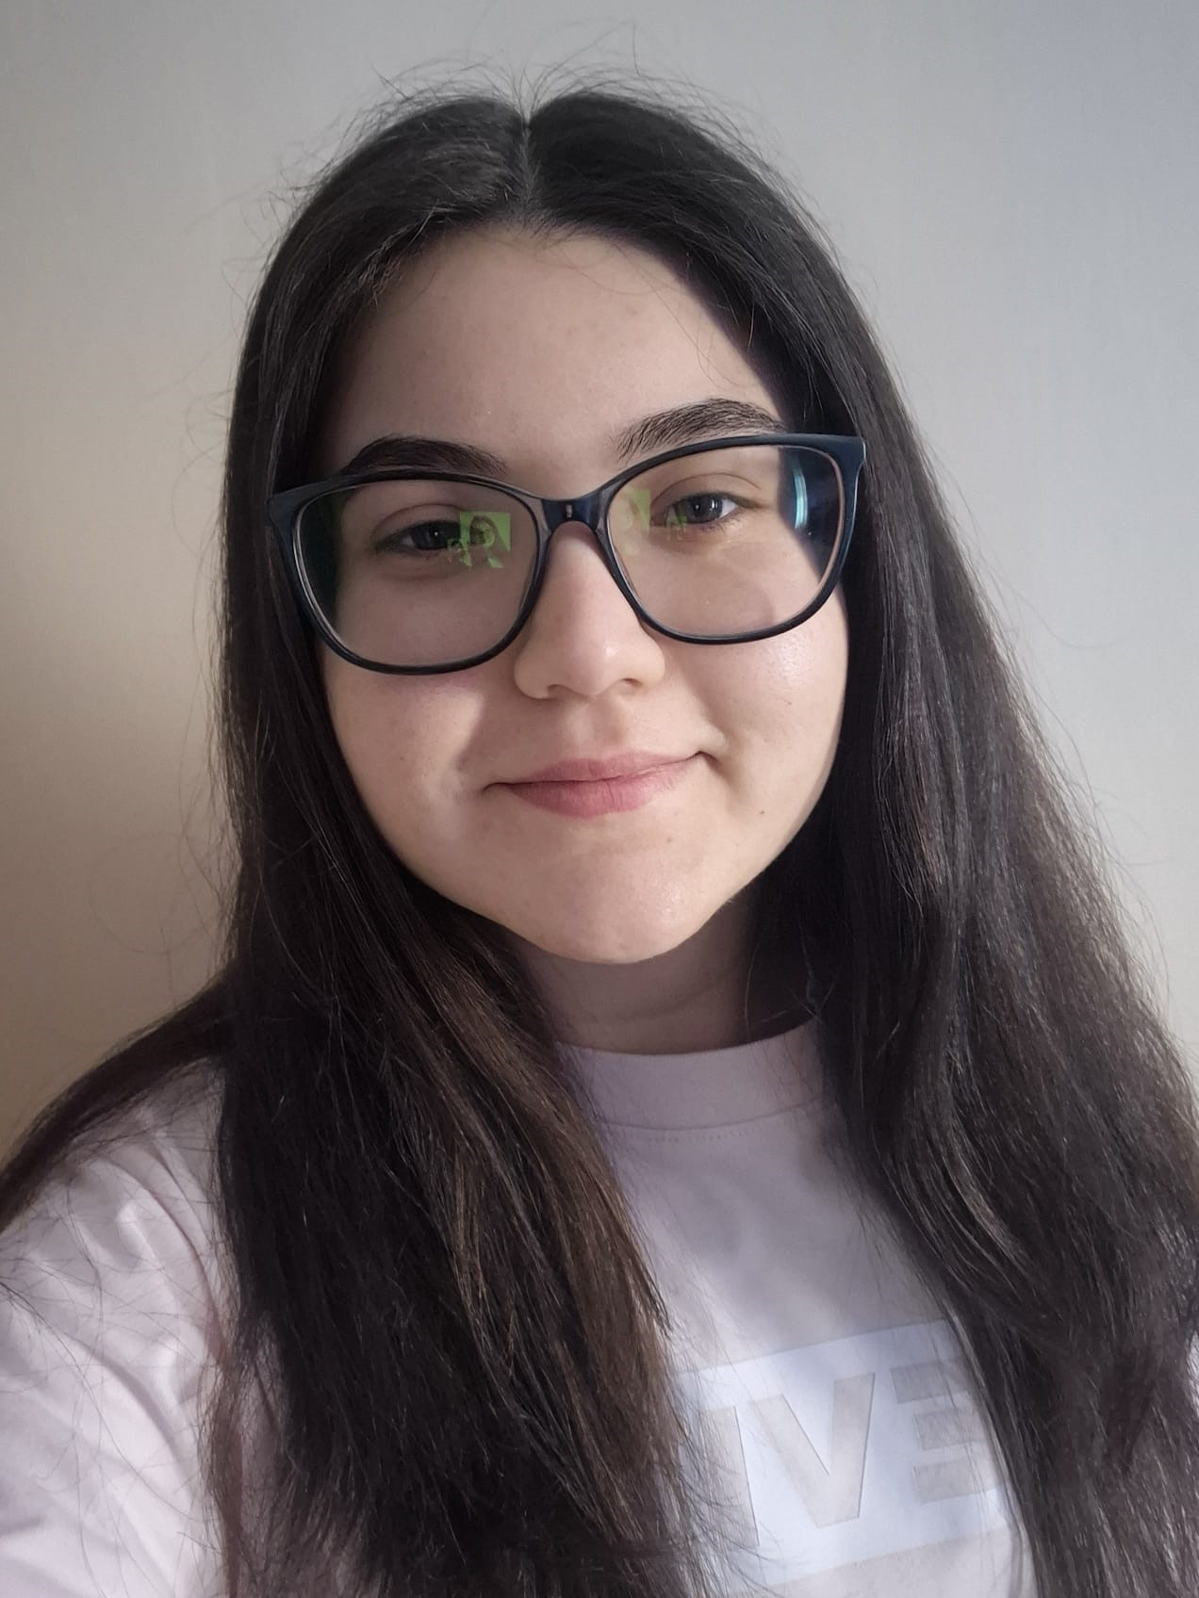

Personal information

E-mail: andreeaelena207@gmail.com
Phone: 0754 363 199
Address: Mioveni, Ion Pillat Street, block N3, staircase A, 3rd floor, apartment 15

About me

Third-year student at the National University of Science and Technology Politehnica of Bucharest University Center of Pitesti, Department of Electronics, Computers and Electrical Engineering.I want to capitalize on my passion for computers and to accumulate as much experience, practice in this IT field, to learn how to work in a real company with professional people.

I learned the following technical and personal skills:
- Microsoft Office;
- MySQL/Oracle/SQL Developer;
- Linux;
- Windows;
- HTML & CSS;
- C++;
- AutoCAD;
- MATLAB & Simulink;
- Ability to work in a team;
- Organized;
- Communicate;
- Responsibility;
- Punctuality;
- Empathy;
- Creativity;
- I learn quickly;

Professional Experience
2023 – Endava for Students Module I Courses

In these courses I learned about Java, Postgre SQL, Spring data, Spring REST Services, HTML and CSS, JavaScript, React, DevOps and Tests based on these programs.

2023 – Internship at Prodinf Software SRL in Pitesti

During the internship I worked in SQL Developer, I realized technical and practical aspects, a session of theory-based questions (Q&A), presentations of SQL Generic and SQL analytical functions.

Education

2021 – present – National University of Science and Technology Politehnica of Bucharest University Center Pitesti, Faculty of Electronics, Communications and Computers, Computer Science Specialization

During my years of study I studied the following subjects: Databases, Applied Informatics, Computer Aided Graphics, Object Oriented Programming, English, Digital Computers, Reconfigurable Hardware Structures, Operating Systems, Computer Networks, Microprocessors and Assembly Languages, Graphic Processing Systems, Operating Systems, and Computer Networks.

2017-2021 – Iulia Zamfirescu Theoretical High School Mioveni
Specialization Mathematics-Computer Science

During my years of study I studied the following subjects: Mathematics, Computer Science, ICT, Physics, English, French.

Foreign Languages Level
Romanian First language
English Medium
French beginner

Other information

I am a person who adapts easily and quickly to new situations. I am always open to learning new things to help me develop professionally as well as possible.
In my free time I enjoy playing video games, spending time with friends and family, and watching series, documentaries and movies. I also hold a category B driver's license.

